OWNERSHIP CERTIFICATE
WWW.SUDHIRRENTALS.COM
To Whom It May Concern

This is to certify that the following equipment listed below is the sole property of Sudhir Equipment Rental Company:

Equipment | Forklift
Brand / Make | HANGCHA
Asset ID | S5FLT-266
Model Number | CPCD50-XRW14
Serial Number | 18BE12395
Capacity | 5 TON
Type | Diesel Forklift
Manufacturing Year | 2026


This certification is issued to confirm the ownership status of the aforementioned equipment. Sudhir Equipment Rental Company holds full legal ownership rights over the listed equipment and retains all associated benefits and responsibilities.
Should there be any queries or requests for verification regarding the ownership of the mentioned equipment, please do not hesitate to contact us at : Info@sudhirrentals.com

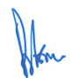
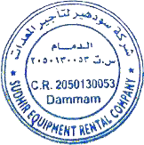
Sincerely,

Rajesh Thakur
Plant Manager
Sudhir Equipment Rental Company

